To determine the correct brand identity based on the entity’s relationship to Curtin University, please complete the following.

Contact details:
Name entity :
Faculty :
Contact name :
Direct contact number :
Email address :

SCREENING QUESTIONS:
- Is there an approval from the relevant Faculty Marketing Team member? Yes / No*
- Is your entity research related? Yes / No
- Is entity an approved Research Centre/ Institute? Yes / No*
- Is there contractual agreement or approval from the VC or relevant Senior Executive Team member? Yes / No*
*if no, this is required before proceeding
- Select the entity type:
  - Strategic Research Institute
  - University Research Institute
  - University Research Centre
  - External Collaborative Research Centres
  - Multi-institutional research centres
  - Cooperative Research Centre (CRC)
  - Other: please describe__________________________________________________________________

1 current name & identity/Logo

What is your entity called? Describe the current brand identity/design being used. Please attach any current logos if applicable.

2 function & strategy
What is the functional purpose of your entity? That is, what do you do? Are there any limitations to your entity in terms of life span? If there is, how long is it (eg Research Centres have a 3 year term)?

3 positioning

Who are your key competitors? Describe what makes your entity unique and different from your competition.

4 equity / funding

Is your entity wholly Curtin university owned? if not, what is the relationship with Curtin (e.g. one of several partners, externally funded, does Curtin have controlling interests, are there contractual obligations)?

5 risk / conflict

Are there any risks that the Curtin brand & reputation may be exposed to?

6 target audience

Describe the key audiences of your entity. Are they internal or external?

7 Budget

What budget is available for design & marketing in the coming 12 months?

Other comments

ENTITY REPRESENTATIVE

Name (first and last name) ______________________________________________
Title ______________________________________________
Signature ______________________________________________ Date_________________

FOR CURTIN UNIVERSITY MARKETING OFFICE USE ONLY

mARKETING mANAGER

BRAND MATRIX RECOMMENDATION BASED ON DECISION TREE
Select one of the brand matrix brand hierarchy options by using the decision tree. Tick the box of the recommended brand hierarchy in the brand matrix.
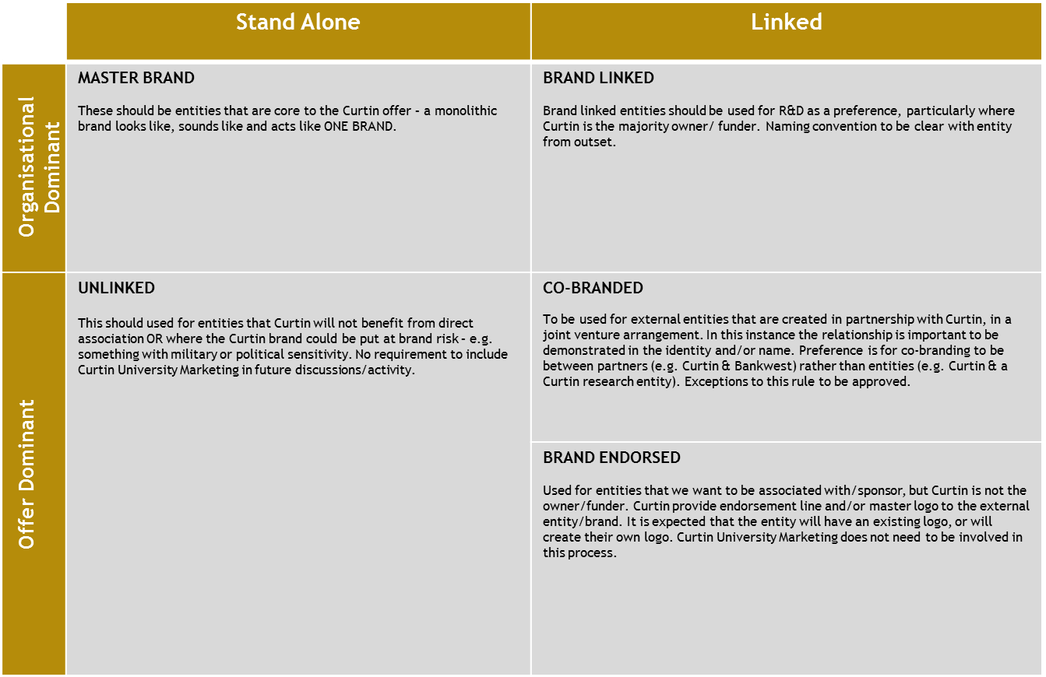

Proudly sponsored by Curtin University

Proudly sponsored by Curtin University
Rationale and/or additional Comments

Name (first and last name) ______________________________________________
Signature ______________________________________________ Date_________________

DIRECTOR BRAND AND MARKETING

Approved Yes / No

Rationale and/or comments (if required)

Name (first and last name) ______________________________________________
Signature ______________________________________________ Date_________________

